27U ENCLOSURE 19" CABINET 800X1000 FLOOR STANDING SERVER RACK - ECO NETCAB
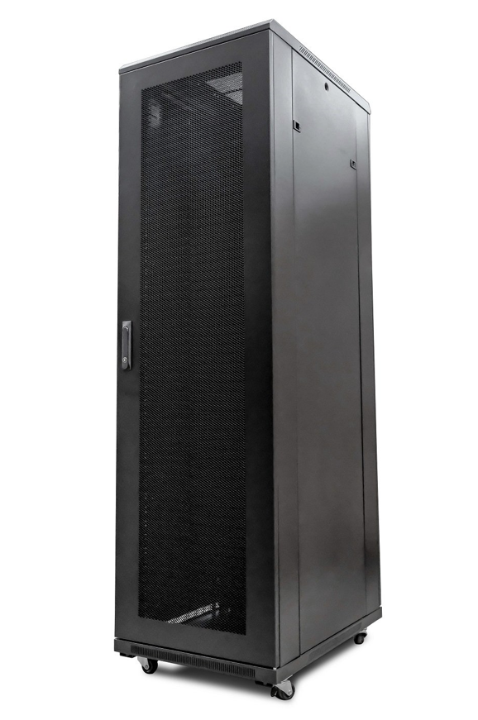

DESCRIPTION
Redefining quality ergonomics for your server and networking needs
Looking to house your rack-mount server, SAN, UPS or other networking devices?
Rack-mount servers and computers are becoming more popular in all sizes of
business, both public and private sector. LMS Data are market leaders in provide
high-quality, best-in-class ergonomics and security for all your server, networking
and broadcasting needs and the new
EcoNetCab server range continues this tradition.
Offering a range of class-leading heights, ideal from the smallest IT ‘closet’
up to large-scale enterprise and data centres with the option for secure access,
co-containment and multiple door option fitments, the LMS Data EcoNetCab is your
ideal partner for your server, SAN and rack-mount UPS containment.

SPECIFICATIONS
ETSI 19” front/rear profiles (adjustable)
800Kg static load bearing
Front mesh high venting door (lockable)
Left or right hinged front/rear doors
Removable side panels for easy access
U-numbered uprights for alignment
Multiple cable entry gland plates
Powder-coated RAL 9005 finish

TECHNICAL INFO
SKU/MPN: CAB-FE-27U-8100
EAN: 8400800015990
Weight: 100.0 Kg
Dimensions: 800x1000x1370mm

FILES
Datasheet - CAB-FE-27U-8100

